The value of ovarian hyperstimulation syndrome along with sexual hormones in predicting in-vitro fertilization outcomes in patients suffering polycystic ovarian syndrome
Shamim Pilehvar¹, nahid radnia², somayeh ahmadiani³, Elaheh Talebi-Ghane⁴, neda alimohammadi⁵, Zahra mousaei tokaldani³*

1- Assistant Professor of infertility and IVF , Clinical Research Development Unit of Fatemieh Hospital, Department of Gynecology, Hamadan University of Medical Sciences, Hamadan, Iran. Sh.pilehvar@yahoo.com
2-Assistant Professor of Female Pelvic Floor Medicine and Surgery , Clinical Research Development Unit of Fatemieh Hospital, Department of Gynecology, Hamadan University of Medical Sciences, Hamadan, Iran. radnia_n@yahoo.com
3- Clinical Research Development Unit of Fatemieh Hospital, Department of Gynecology, Hamadan University of Medical Sciences Hamadan, Iran. snor.ahmadiani@yahoo.com
4- Assistant Professor of biostatistics, modeling of noncommunicable diseases research center, Hamadan University of Medical Sciences Hamadan, Iran. talebi_ghane@yahoo.com
5- MSc of nursing, Clinical Research Development Unit of Fatemieh Hospital, Hamadan University of Medical Sciences, Hamadan, Iran. Nalimohamadi68@yahoo.com

Corresponding auther: Zahra mousaei tokaldani
Fax: +98 8131314048
Tell: 09364566574
Email: dr.mosaei1366@gmail.com
ORKID: 0000-0002-6902-3003
ORKID SONOR: 0000-0003-4077-4054
خق
ABSTRACT
Background:Ovarian hyperstimulation syndrome(OHSS) as a known complication in polycystic ovarian syndrome(PCOS) women may occur following inducible fertility treatments such as in-vitro fertilization(IVF) and also can affect the sequels of these fertility treatments. The aim of this study was to first assess the effects of OHSS on pregnancy outcome related to IVF in PCOS patients and second to compare the values of AMH and LH to FSH ratio in patients with PCOS treated with IVF with and without OHSS.
Methods:This case-control study was conducted on consecutive women suffering PCOS that were candidate for IVF. The patients were assigned into the case group with OHSS and control group without OHSS. Measurements of AMH, LH and FSH in patients were performed using enzyme-linked immunosorbent assay(ELISA).Patients in both groups were followed up for chemical and clinical pregnancy up to 8-weeks after IVF.
Results: There was no difference between the two groups with and without OHSS in the mean of endometrial thickness and also the number of embryo transferred. Although the rate of chemical pregnancy and clinical pregnancy were both significantly higher in those with OHSS than in the control group, in multivariable logistic regression models OHSS could not predict the likelihood of clinical or chemical pregnancy following IVF. None of the baseline sexual hormones could predict the successful chemical or clinical pregnancy in the PCOS women with and without OHSS following IVF.
Conclusion: OHSS may not influence IVF-related outcome in PCOS patients.the pointed outcome may not also be determined by the valuesof sexual hormones.
Keyword: ovarian hyper stimulation syndrome, sexual hormones, polycystic ovarian syndrome

INTRODUCTION
Polycystic ovarian syndrome (PCOS) is one of the most common disorders of the endocrine system in women of childbearing age, with prevalence ranged 5 to 15% in various studies and is one of the most important causes of infertility in women (1). Women with this syndrome include a large group of women with non-ovulatory problems in the clinic (70 to 80%) (2). There is still no general consensus on definitive diagnostic criteria for PCOS, and due to the great variety of signs and symptoms of this syndrome, there are challenges in its management and care especially with respect to fertility recovery. Moreover, the etiology of PCOS is still unclear, however genetic predisposition, increased insulin secretion, insulin resistance, increased body mass index and chemical and even environmental contaminants are possible causes of disease (3,4). Pregnant women with PCOS are at risk for gestational diabetes, preeclampsia, premature birth, increased risk of infant death and the need for neonatal intensive care units (NICUs) (5,6). Pregnant women with PCOS may experience different risky conditions during pregnancy, including abortion and congenital malformations in the first trimester, and impaired glucose tolerance, gestational diabetes, hypertension, and preeclampsia in the second and third trimesters (7,8). Due to reproductive complexity in these patients caused by hormonal disturbances, IVF in women with PCOS is associated with a variety of challenges, from poor ovarian response to uncontrolled ovarian response.
Ovarian hyperstimulation syndrome (OHSS) is a complication sourced by excessive stimulation of ovulation that occurs in 1 to10% of IVF and embryo transfer cycles (9). Although mild OHSS has no clinical significance, severe OHSS is a life-threatening complication (10). Severe cases of OHSS are characterized by severe ascites, marked increase in ovarian size, hydrothorax, oliguria, increased hemoglobin, and electrolyte disturbances (11). In patients with PCOS, ovarian stimulation should be programmed according to serum level of antimullerian hormone (AMH), number of antral follicles and especially serum follicle stimulating hormone (FSH) and Luteinizing hormone (LH) levels (12). The dose of stimulant gonadotropin should be programmed to achieve an optimal response during a GnRH antagonist cycle. AMH is reported to be a reliable indicator of the ovarian response to controlled ovarian stimulation (13). Overall, the most important risk for PCOS patients who are candidates for IVF is OHSS, which may be predictable by measuring hormones before treatment (14). The aim of this study was to first assess the effects of OHSS on pregnancy outcome related to IVF in PCOS patients and second to compare the values of AMH and LH to FSH ratio in patients with PCOS treated with IVF with and without OHSS.

MATERIALS AND METHODS
This case-control study was conducted on consecutive women suffering PCOS that were candidate for IVF at Fatemiyeh hospital in Hamadan, Iran in 2022. The inclusion criteria were the diagnosis of PCOS according to Rotterdam criteria along with the presence of OHSS, scheduling IVF, and aged 18 to 42 years. In this study, the diagnosis of PCOS was based on the Rotterdam (2003) criteria which includes at least two of the following four criteria a) the existence of irregular menstrual cycle, b) clinical and biochemical evidences of hyperandrogenism and hirsutism, c) the presence of polycystic ovaries on ultrasonography including more than 12 follicles in each ovary with a diameter of at least 3mm with or without ovarian volume increase and d) the elimination of other causes of menstrual irregularity or hyperandrogenism such as congenital adrenal hyperplasia, androgen-secreting tumors, and definite hyperprolactinemia (15). Severe systemic disease such as liver, cardiovascular and kidney disease or serum testosterone level exceeds 7 ng/ml were considered as the exclusion criteria. Written consent was obtained from all study participants to begin the study. Necessary permission was also obtained from the ethics committee of Hamadan University of Medical Sciences to conduct the study. Information about the treatment method, the amount of drugs used; serum levels of estradiol on the day of HCG injection, age, body mass index (BMI), cause of infertility, occurrence and severity of OHSS were extracted from patients' records in hospital. Based on the presence of OHSS, the patients were assigned into the case group with OHSS and control group without OHSS. The case group consisted of people in whom the stimulation of controlled ovulation led to OHSS and in control group, the pointed condition was not observed. It should be noted that these two groups were age-matched. The diagnosis of OHSS as also based on criteria published in 2016 that emphasized moderate abdominal pain, nausea and vomiting, ascites, and bilateral ovarian enlargement (16). Regarding IVF protocol, agonist protocol was used in both groups. The size of the follicle was controlled by ultrasound and after reaching the size of at least 17 to18 mm, the ampoule of oocytes releasing trigger was prescribed and the oocytes were removed 36 hours later. The fertilization was finally performed by an embryologist. Patients in both groups were followed up for study endpoints including chemical and clinical pregnancy up to 8 weeks after IVF. The protocol was started from the cycle before the onset of OCP gonadotropin and began from 21 cycles of GNRH agonist for hormonal suppression. After discontinuation of OCP and menstruation, gonadotropin was started at the appropriate dose based on the patient's condition. Measurements of AMH, LH and FSH in patients were performed using enzyme-linked immunosorbent assay (ELISA). Patients in both groups were followed up for chemical and clinical pregnancy up to 8 weeks after IVF.
For statistical analysis, results were presented as mean ± standard deviation (SD) for quantitative variables and were summarized by frequency (percentage) for categorical variables. Continuous variables were compared using t test or Mann-Whitney U test whenever the data did not appear to have normal distribution or when the assumption of equal variances was violated across the study groups. The categorical variables were compared using the Chi-Square test. P values of ≤ 0.05 were considered statistically significant. For the statistical analysis, the statistical software SPSS version 23.0 for windows (IBM, Armonk, New York) was used.

RESULTS
Comparing the two groups with and without OHSS (Table 1) showed no difference in average age or history of IVF, however those with OHSS had significantly lower BMI, had higher number of oocytes, as well as suffered more from hirsutism. With respect to hormonal status, the mean serum level of AMH was significantly higher in the group with OHSS, while we found no difference in the levels of prolactin, TSH, FSH, or LH.
Regarding IVF and pregnancy outcome, there was no difference between the two groups with and without OHSS in the mean of endometrial thickness (9.17±0.85 versus 9.21±0.87, p = 0.785) and also the number of embryo transferred (2.98±1.31 versus 3.04±1.47, p = 0.807). The rate of chemical pregnancy (37.2% versus 19.6%, p = 0.023) and clinical pregnancy (31.8% versus 13.7%, p = 0.014) were both significantly higher in those with OHSS than in the control group, but no difference was found in the rate of abortion between the two groups (9.3% versus 7.8%, p = 0.757). However, in multivariable logistic regression models (Tables 2 and 3), OHSS could not predict the likelihood of clinical or chemical pregnancy following IVF.
According to the ROC curve analysis (Table 4 and Figure 1); none of the baseline sexual hormones could predict the successful chemical or clinical pregnancy in the PCOS women with and without OHSS following IVF.

DISCUSSION
OHSS as a known complication in PCOS women may occur following inducible fertility treatments such as IVF and also can affect the sequels of these fertility treatments. It seems that those women who suffering OHSS following IVF protocol may experience significantly lower clinical or chemical pregnancies despite increasing the oocytes production and retrieving. It should be of course noted that applying novel fertility inducible techniques could lead to increase the chance for fertility except to more severe cases. As shown previously by Arieh Raziel et al (17), patients with severe OHSS are exposed to more adverse pregnancy outcome even in early stages of IVF such as hemodynamic instability, hypoxia, increasing endogenous estrogens and increasing the secretion of some prostaglandins. However it remains unclear whether the appearance of OHSS in the field of PCOS may affect pregnancy successfulness following IVF. Interestingly, even the onset of this syndrome may be associated with an increased risk of pregnancy. As shown in the present study, both clinical and chemical pregnancy as the consequences of IVF following PCOS may be significantly increased in OHSS patients, however using the multivariable regression modeling and adjusting baseline probable confounders, the effect of OHSS on pregnancy rate disappeared. In other words, the reason for the increase in pregnancy rate may have been other underlying variables, especially the level of primary sex hormones in cases with this complication. In the next step and using ROC curve analysis, we ruled out the role of sex hormones on the pregnancy outcome following IVF, while history of amenorrhea and obesity state may be the main determinants of fertility failure in such patients. In other words, it seems that the role of these hormones, especially AMH may at least be completely questioned in our community. Some authors have shown that AMH is a reliable parameter in predicting ovarian response to controlled ovarian stimulation as well we with the ultrasonographic findings of antral follicle count (AFC) (18). Some authors even showed that the value of AMH may efficient in predicting ovarian response and OHSS than female age and body mass index (19). Therefore, it is not yet clear which clinical or laboratory markers will be able to predict the outcome of IVF in such patients and will require further evaluation with a larger sample size.
CONCLUSION
It can be finally concluded that no significant difference is expected in IVF-related outcome including clinical or chemical pregnancy between the PCOS groups with and without OHSS. In other words, the occurrence of OHSS in such patients may not be a main determinants for IVF poorer outcome. Contrary to popular belief, laboratory markers, especially sex steroids, may not predict the outcome of IVF in these patients.
Acknowledgments
The authors would like to appreciate the sincere support of the vice-chancellor for Hamadan University of Medical Sciences, Fatemieh Clinical Research Development Unit, Hamadan, and the respected staff of the prenatal ward.
Conflict of Interest
no

REFERENCES
1. Sadeghi HM, Adeli I, Calina D, Docea AO, Mousavi T, Daniali M, Nikfar S, Tsatsakis A, Abdollahi M. Polycystic Ovary Syndrome: A Comprehensive Review of Pathogenesis, Management, and Drug Repurposing. Int J Mol Sci. 2022 Jan 6;23(2):583
2. Motlagh Asghari K, Nejadghaderi SA, Alizadeh M, Sanaie S, Sullman MJM, Kolahi AA, Avery J, Safiri S. Burden of polycystic ovary syndrome in the Middle East and North Africa region, 1990-2019. Sci Rep. 2022 Apr 29;12(1):7039.
3. Nautiyal H, Imam SS, Alshehri S, Ghoneim MM, Afzal M, Alzarea SI, Güven E, Al-Abbasi FA, Kazmi I. Polycystic Ovarian Syndrome: A Complex Disease with a Genetics Approach. Biomedicines. 2022 Feb 24;10(3):540.
4. Rashid R, Mir SA, Kareem O, Ali T, Ara R, Malik A, Amin F, Bader GN. Polycystic ovarian syndrome-current pharmacotherapy and clinical implications. Taiwan J Obstet Gynecol. 2022 Jan;61(1):40-50.
5. Parker J, O'Brien C, Hawrelak J, Gersh FL. Polycystic Ovary Syndrome: An Evolutionary Adaptation to Lifestyle and the Environment. Int J Environ Res Public Health. 2022 Jan 25;19(3):1336.
6. Pei CZ, Jin L, Baek KH. Pathogenetic analysis of polycystic ovary syndrome from the perspective of omics. Biomed Pharmacother. 2021 Oct;142:112031.
7. Yang H, Xiao YQ, Liu JJ, Xu GX, Li J, Xiao ZY, Zhou J, Zheng XY, Liu LY, Yu Z, Yang J, Liang FR. Effect of non-pharmacological interventions for overweight/obese women with polycystic ovary syndrome on ovulation and pregnancy outcomes: a protocol for a systematic review and network meta-analysis. BMJ Open. 2022 Jun 8;12(6):e059090.
8. Yang H, Xiao YQ, Liu JJ, Xu GX, Li J, Xiao ZY, Zhou J, Zheng XY, Liu LY, Yu Z, Yang J, Liang FR. Effect of non-pharmacological interventions for overweight/obese women with polycystic ovary syndrome on ovulation and pregnancy outcomes: a protocol for a systematic review and network meta-analysis. BMJ Open. 2022 Jun 8;12(6):e059090.
9. Li D, Guo Y, Lu S, Zhong Y, Zhu W, Liu Q. Analysis of 24 cases of polycystic ovary syndrome after failed controlled ovarian hyperstimulation. Clin Med (Lond). 2019 Jul;19(4):350-352.
10. Tanbo T, Mellembakken J, Bjercke S, Ring E, Åbyholm T, Fedorcsak P. Ovulation induction in polycystic ovary syndrome. Acta Obstet Gynecol Scand. 2018 Oct;97(10):1162-1167.
11. Chen Y, Ye B, Yang X, Zheng J, Lin J, Zhao J. Predicting the outcome of different protocols of in vitro fertilization with anti-Muüllerian hormone levels in patients with polycystic ovary syndrome. J Int Med Res. 2017 Jun;45(3):1138-1147.
12. Seok HH, Song H, Lyu SW, Kim YS, Lee DR, Lee WS, Yoon TK. Application of serum anti-Müllerian hormone levels in selecting patients with polycystic ovary syndrome for in vitro maturation treatment. Clin Exp Reprod Med. 2016 Jun;43(2):126-32.
13. Melado Vidales L, Fernández-Nistal A, Martínez Fernández V, Verdú Merino V, Bruna Catalán I, Bajo Arenas JM. Anti-Müllerian hormone levels to predict oocyte maturity and embryo quality during controlled ovarian hyperstimulation. Minerva Ginecol. 2017 Jun;69(3):225-232.
14. Melado Vidales L, Fernández-Nistal A, Martínez Fernández V, Verdú Merino V, Bruna Catalán I, Bajo Arenas JM. Anti-Müllerian hormone dynamics during GNRH-antagonist short protocol for IVF/ICSI in women with varying ovarian reserve levels. Minerva Ginecol. 2017 Apr;69(2):128-134.
15. van Keizerswaard J, Dietz de Loos ALP, Louwers YV, Laven JSE. Changes in individual polycystic ovary syndrome phenotypical characteristics over time: a long-term follow-up study. Fertil Steril. 2022 May;117(5):1059-1066.
16. Bahia Namavar Jahromi MD 1 2, Mohammad Ebrahim Parsanezhad MD 1 2, Zahra Shomali MD 2 3, Pardis Bakhshai MD 2 3, Mahshid Alborzi MD 2 3, Najmeh Moin Vaziri MD PhD 1, Zahra Anvar PhD 1. . Ovarian Hyperstimulation Syndrome: A Narrative Review of Its Pathophysiology, Risk Factors, Prevention, Classification, and Management. Iran J Med Sci 2018 May;43(3):248-260.
17. Arieh Raziel 1, Morey Schachter, Shevah Friedler, Raphael Ron-El. Outcome of IVF pregnancies following severe OHSS. Reprod Biomed Online. 2009 Jul;19(1):61-5. doi: 10.1016/s1472-6483(10)60047-8.
18. Cook CL, Siow Y, Taylor S, et al. Serum mullerian-inhibiting substance levels during normal menstrual cycles. Fertil Steril. 2000;73:859–861.
19. Lee TS, Liu CH, Huang CC, et al. Serum AMH and estradiol levels as predictors of OHSS in ART cycles. Hum Reprod. 2008;23(1):160–167.

Table 1: Baseline characteristics in study population
Characteristics | Group with OHSS | Group without OHSS | P value
Mean age, year | 31.16±5.54 | 30.20±4.81 | 0.280
Mean body mass index, kg/m² | 25.81±3.24 | 27.23±4.04 | 0.028
Mean number of oocytes | 17.80±8.40 | 13.59±7.67 | 0.002
Mean level of LH, ng/ml | 8.03±5.21 | 8.22±6.46 | 0.837
Mean level of prolactin, mg/dl | 26.08±2.59 | 28.36±5.81 | 0.679
Mean level of TSH, mg/dl | 2.28±0.11 | 2.60±0.19 | 0.153
Mean level of AMH, ng/ml | 8.59±5.25 | 6.50±4.81 | 0.017
Mean level of stradiol, ng/ml | 40.31±4.00 | 47.67±7.83 | 0.257
Mean level of FSH, ng/ml | 5.65±1.92 | 6.00±1.81 | 0.281
Mean level of vitamin D, mg/dl | 27.30±11.49 | 31.15±15.12 | 0.113
Duration of PCOS, month | 5.45±3.32 | 4.67±2.90 | 0.144
Irregular menstrual cycle | 61 (47.3) | 19 (37.3) | 0.222
History of IVF | 42 (33.1) | 20 (39.2) | 0.437
Amenorrhea | 17 (13.2) | 2 (3.9) | 0.104
Hirsutism | 45 (34.9) | 10 (19.6) | 0.045

Table 2: The association of OHSS with the rate of chemical pregnancy adjusted for baseline parameters
Characteristics | Beta | P value | Odds Ratio  (OR) | 95%CI for OR
 |  |  |  | Lower limit | Upper limit
Presence of OHSS | 0.216 | 0.702 | 1.241 | 0.410 | 3.754
Age | 0.031 | 0.553 | 1.031 | 0.931 | 1.142
Mean body mass index | 0.074 | 0.266 | 1.077 | 0.945 | 1.227
Mean number of oocytes | -0.025 | 0.375 | 0.975 | 0.922 | 1.031
Mean level of LH | 0.008 | 0.874 | 1.008 | 0.917 | 1.108
Mean level of prolactin | -0.006 | 0.370 | 0.994 | 0.980 | 1.008
Mean level of TSH | 0.134 | 0.499 | 1.143 | 0.776 | 1.686
Mean level of AMH | -0.004 | 0.933 | 0.996 | 0.910 | 1.090
Mean level of stradiol | 0.001 | 0.803 | 1.001 | 0.990 | 1.012
Mean level of FSH | -0.207 | 0.086 | 0.813 | 0.642 | 1.030
Mean level of vitamin D | 0.015 | 0.464 | 1.015 | 0.975 | 1.056
Duration of PCOS | -0.019 | 0.825 | 0.981 | 0.826 | 1.165
Primary type of infertility | -0.786 | 0.122 | 0.456 | 0.168 | 1.234
Irregular menstrual cycle | -0.363 | 0.420 | 0.696 | 0.288 | 1.679
History of IVF | 0.671 | 0.147 | 1.957 | 0.789 | 4.854
Amenorrhea | 1.902 | 0.019 | 6.696 | 1.360 | 32.977
Hirsutism | -0.196 | 0.733 | 0.822 | 0.266 | 2.540

Table 3: The association of OHSS with the rate of clinical pregnancy adjusted for baseline parameters
Characteristics | Beta | P value | Odds Ratio  (OR) | 95%CI for OR
 |  |  |  | Lower limit | Upper limit
Presence of OHSS | -0.207 | 0.757 | 0.813 | 0.219 | 3.013
Age | 0.056 | 0.362 | 1.058 | 0.937 | 1.195
Mean body mass index | 0.233 | 0.007 | 1.262 | 1.066 | 1.495
Mean number of oocytes | -0.084 | 0.016 | 0.919 | 0.859 | 0.984
Mean level of LH | 0.020 | 0.723 | 1.021 | 0.912 | 1.142
Mean level of prolactin | -0.014 | 0.081 | 0.986 | 0.971 | 1.002
Mean level of TSH | 0.261 | 0.259 | 1.298 | 0.825 | 2.044
Mean level of AMH | 0.064 | 0.289 | 1.066 | 0.947 | 1.199
Mean level of stradiol | 0.000 | 0.983 | 1.000 | 0.988 | 1.012
Mean level of FSH | -0.402 | 0.009 | 0.669 | 0.495 | 0.904
Mean level of vitamin D | 0.031 | 0.188 | 1.031 | 0.985 | 1.080
Duration of PCOS | -0.024 | 0.817 | 0.976 | 0.796 | 1.198
Primary type of infertility | -0.662 | 0.264 | 0.516 | 0.162 | 1.647
Irregular menstrual cycle | -0.214 | 0.674 | 0.807 | 0.298 | 2.187
History of IVF | 0.933 | 0.096 | 2.542 | 0.846 | 7.637
Amenorrhea | 3.505 | 0.001 | 33.288 | 4.366 | 53.772
Hirsutism | -0.367 | 0.590 | 0.693 | 0.183 | 2.630

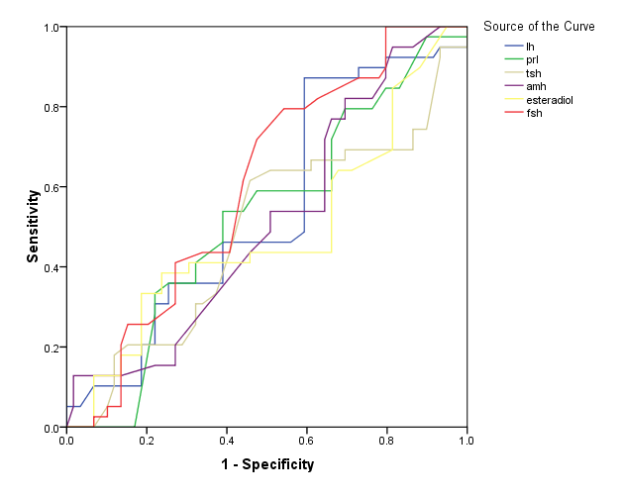
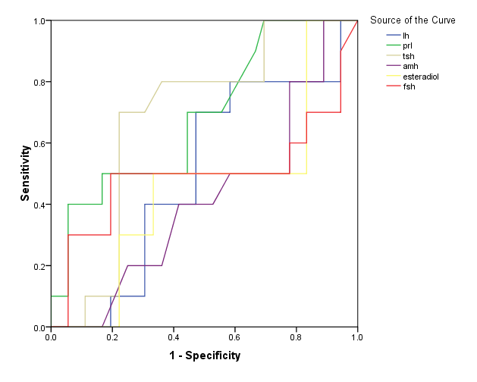
Figure 1: The ROC curve analysis to assess the value of laboratory parameters in predicting successfulness of chemical pregnancy (A: OHSS (+), B: OHSS (-))

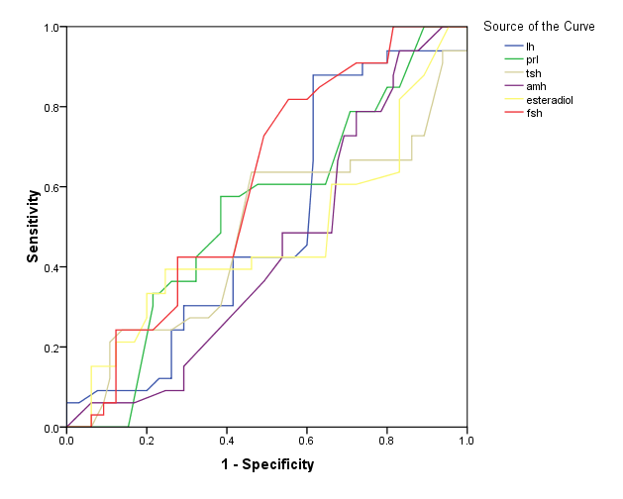

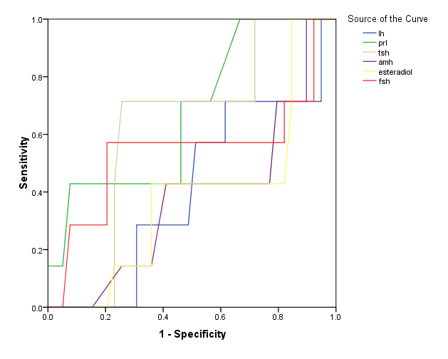
Figure 2: The ROC curve analysis to assess the value of laboratory parameters in predicting successfulness of clinical pregnancy (A: OHSS (+), B: OHSS (-))

